
DELTA SIGMA PHI FRATERNITY
Epsilon Rho Chapter – Cal Poly / SLO
Alumni Corporation Board

(Incorporated Name: “Delta Sigma Phi Fraternity of San Luis Obispo, Alumni Control Board, Inc.”)

Date: May 31, 2015

To: Mr. Cameron Warner, Director of Risk Management and Housing
Mr. Patrick Jesse, JD, Executive Director
Delta Sigma Phi Fraternity - National Headquarters

From: The Alumni Corporation Board of the Epsilon Rho Chapter of Delta Sigma
Phi Fraternity at Cal Poly / SLO

Re: Contribution To Appeal Process of the University’s May 12, 2015 Decision

INTRODUCTION

The following is the formal response by the Alumni Corporation Board (ACB) of the Epsilon Rho Chapter of Delta Sigma Phi Fraternity (DSP) at Cal Poly / SLO to the University’s May 12, 2015, decision to remove campus recognition from our organization.

It is our preference that our National Fraternity conveys this message, in its entirety, to Cal Poly as part of the appeal package. Should our National Fraternity believe it best only to incorporate elements of this message into their appeal package, we support this judgment.

The elected officers of the ACB are DSP alumni of Cal Poly. They, and the advisors they appoint, represent the 1,500 Cal Poly Delta Sigma Phi alumni since 1950.

ACB’s Purpose

From an organizational perspective, the ACB owns the chapter property and is responsible for directing the many aspects of the fraternal program. This program includes providing activities and an environment conducive to personal growth development. Personal growth occurs through formal leadership training and the practical application of this training in chapter self-governance. Growth occurs from learning how to effectively live and plan and manage and work together within a diverse group of men, majors, and interests. Other formal elements of our program include respect for our nation’s institutions and ideals, attainment of academic excellence, involvement in campus clubs and government, service to community, and chivalrous conduct toward women. The program stresses numerous National Fraternity, University, and additional ACB originated risk-management measures to promote student health and safety of members and their guests.

From a brotherly perspective, the ACB is also the conduit by which six decades of Cal Poly Delta Sig alumni provide oversight, guidance, and their expectations for our chapter, program, values, men, conduct, and reputation.

We Share The Same Objectives

Our alumni, the ACB, and the Chapter’s elected board of undergraduate officers embrace the ideals of our National Fraternity and of Cal Poly. We wish to partner with National and Cal Poly in promoting our shared values and objectives for our student organization and its members.

Cal Poly’s Concerns

ACB feels that Cal Poly’s internal review of its May 12, 2015 decision will be benefitted by having the following, additional, relevant information. This information focuses on the three primary questions the University addressed to our Chapter President during the May 8, 2015, hearing. Paraphrased, these three areas of concern were: what is your fraternal process for management; how does your fraternity protect the health and safety of its members and the student body; and, what value does your fraternity provide its members, Cal Poly, and the student body.

ACB Agrees These Are Reasonable Questions

We absolutely agree that these are reasonable questions for any University student organization. We completely agree that the degree of demonstrated organizational commitment to these three criteria, and to related standards, should be the measure by which organizational responsibility is measured.

To this end, the following addresses the three questions of process, health and safety, and organizational value – and related standards.

Time-Line

We have limited our response to the time-line relevant to Cal Poly’s concerns. Unless past events (Part #1) have a direct bearing on addressing Cal Poly’s questions, we focus on the period from September 2012 forward. In September 2012 ACB launched a comprehensive “Culture Change Program” at our chapter (Part #2). Part #3 addresses operations from September 2012 to September 2014. Due to its relevance, we separately report on operations since the September 4, 2014 arrest – the 2014-2015 academic year (Part #4). This will allow Cal Poly’s appeal board to identify the post-arrest period of chapter betterment activities that occurred during this school year. This period saw significant program review and member education of their responsibilities.

Proposed Future Program Changes

The last section of this report describes our proposed program changes for future operations (Part #5).

The first proposed change would greatly promote chapter oversight. There is no greater predictor of a chapter’s success than the number and involvement of those who provide adult supervision and guidance.

The other proposed program change would help mitigate the risks associated with recruiting and initiating first-quarter freshmen. Our recruitment proposal would directly and immediately benefit our chapter.

While both these program proposal will benefit the chapter, we feel the second proposal may also be of significant assistance to Cal Poly. We feel the University could point to our two-year revised-recruitment test-program as a model for other IFC members to consider. Fraternities wanting to reduce their (and the University’s) risk exposure could voluntarily, avoiding NIC involvement, adopt our practice that is expected to reduce risk while not reducing annual membership recruitment goals.

PART 1: RELEVANT PAST EXAMPLES - OUR FRATERNITY’S VALUE TO MEMBERS, TO CAL POLY, AND TO THE COMMUNITY

In response to Cal Poly’s hearing question of what value our Fraternity provides, a few past examples lay the groundwork for our focus on contributions of today – and establish that our contribution is one of many decades. Some contributions, like those in members’ character and those to the needs of less fortunate people, only reside in memory. Other contributions leave behind physical monuments.

Historic Example – Value Of Our Fraternity To Members
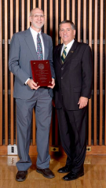
Cal Poly President Jeff Armstrong (right) presents “Alumni Of The Year For The School Of Architecture And Environmental Design” in 2013 to Paul Hamalian (left), a Cal Poly Delta Sig from Fall 1983.

About the honor, Paul said, “The award was unexpected, as I have had little contact with Cal Poly.” In reflecting on his experience as a Brother at our chapter at Cal Poly, he said, “I don’t use much of my construction competencies, but I definitely use the leadership and people-skills learned as the chapter’s Housing Manager and then as VP at Delta Sigma Phi.” (source: Alumni Newsletter, Spring 2014)

Historic Examples – Value Of Our Fraternity To Cal Poly

The Poly P

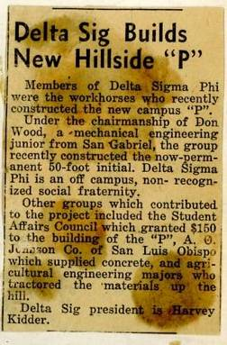
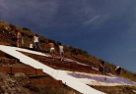
“The Poly P, on Poly Mountain above campus, a symbol of pride for Poly students, is one of the oldest hillside initials on the West Coast. In 1919, local high school students formed an “H” on Poly Mountain from large stones, and Cal Poly students changed it to a “P”. In the early 1920’s, a 24 by 40 foot “P” with a stone perimeter and lime-filled interior was built. This version was later replaced with white-washed barn doors to form the college’s “Block P”. This symbol was falling apart in the 1950’s and, on their own initiative, the members of Delta Sigma Phi Fraternity built the modern “Poly P’ in 1957. The Fraternity’s engineering majors designed the “P” to be seen from campus, town, and from aircraft.

Article courtesy of Telegram-Tribune. Photo courtesy of Delta Sigma Phi – 1981 Fraternity workday to maintain the Poly P. (Source: DSP Alumni Newsletter, March 2011)

The Bronze Mustang Sculpture

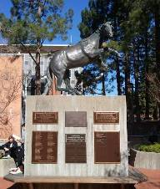
“Although undergraduate students on limited budgets, the “BROTHERS OF DELTA SIGMA PHI” were the only Fraternity to answer the call of campus to donate to Cal Poly’s famous bronze – “The Mustang”. This eight-foot tall sculpture by Dr. Ray Harris cost $33,000 and was unveiled during Poly Royal on April 25, 1982. It is just outside the UU. Brothers gave $1,000 and our credit appears three names above that of President Ronald Reagan.”
(source: Alumni Newsletter, March 2011)
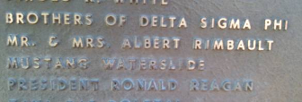

Involvement In Campus Government

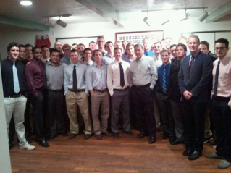
“At the invitation of our undergraduate members, Cal Poly’s President Armstrong dined at the chapter on February 7th as part of the Engineered Leadership program of guest speakers. President Armstrong is Cal Poly’s new president and a member of AGR. Delta Sigma Phi is the first fraternity at Cal Poly where he has dined.

Dinner went extremely well, and he was pleased to see so many members of student government and the IFC President – all Delta Sigs. Brothers asked great questions at the end of dinner.”
(source: Alumni Newsletter, Winter 2012)

Historic Examples – Value Of Our Fraternity To Community
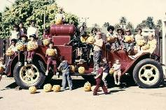
From the 1950’s through 1980’s, Delta Sigma Phi Fraternity/s primary philanthropy was to help the underprivileged children in the San Luis Obispo area.

We annually hosted a Pumpkin Carve and Christmas Party for these children.

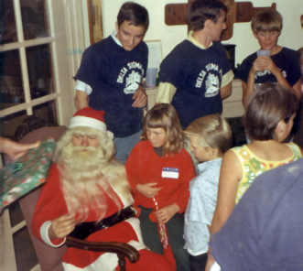
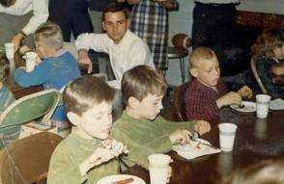



Our Brothers planned these parties, purchased the pumpkins and gifts and did the wrapping, organized the food and games, and gave of their time so needy children could enjoy a wonderful holiday too.
PART 2: SEPTEMBER 2012 ACB INSTILLATION OF “CULTURE CHANGE PROGRAM” AT CHAPTER

Preparation for the September 2012 implementation of ACB’s Culture Change Program began with removing alcohol from the chapter property, promoting financial responsibility by members, and establishing high-character-level standards for recruitment of New Members.

Beginning in September 2012, ACB meetings were held at the chapter to introduce, and gain the chapter’s commitment to using, a custom-developed “Leading By Values” model. This values-based decision-making model guides personal and group decisions by comparing potential behavior (before-the-fact), and actual behavior (after-the-fact), to value-driven standards of conduct committed to by membership.

ACB President’s Message To Alumni And Undergraduates (Excerpts)
July 31, 2012

We as brothers, both alumni and undergraduate, will no longer tolerate unacceptable, un-brotherly, personal or group conduct by members of our chapter. New strategies and policies are being introduced, and actions taken, to build a better brotherhood based on values and character.

We are bringing an end to the alcohol-related problems at our chapter house - including the many risks they present. We are transforming our chapter from one that is average by today’s standards, one which at times demonstrates unacceptable behavior, to the leading fraternity at Cal Poly.

The following comprehensive strategy will be implemented at our chapter when ACB holds a special weekend meeting there in September 2012. We all want the same results from our chapter and its program. These include:
1. Improving respect for and appearance of chapter property;
2. Maintaining our financial integrity to reinvest in our chapter;
3. Developing better men by, in part, promoting leadership and a service-orientation;

We need to manage our core risks:
1. Alcohol and this generation’s periodic practice of binge-drinking;
2. Recruiting the wrong guys and rushing to the wrong standards;
3. Waste and unpaid bills - that in the past have reduced our treasury.

Starting in September we will be re-grounding, and putting in place, policies to minimize our risks, improve the quality our chapter’s program, and build the character of our men.

Our new alcohol policy will be:
1. Our chapter house will be dry (no alcohol) at all times unless pre-approval is given by ACB for a special event. If ACB gives pre-approval, the chapter must follow national’s alcohol risk-management policies;
2. At least once a month, on an unannounced basis, an alumni assigned by ACB will inspect the house for signs of alcohol;
3. Each failure of the chapter’s Exec. Board to enforce this policy will result in a 25% reduction in officer compensation for the year and trigger a 2nd unannounced audit in the same month.

Our new financial policy will be:
- ACB will no longer lend the chapter money because of mismanagement, waste, and lack of adequate budgeting;
- For each $2,000 in unpaid receivable, the chapter will prorate and collect $25 from each member.

It is time we refocus on helping our men to learn and grow and lead with our core values. These values will be presented in September. We have good guys there now. With the right management, leadership, and alumni coaching, DSP at Cal Poly will again return to the best chapter in the nation.

Respectfully,
Brother Bob Veazie, Spring 1976

(source: Alumni web site, www.CalPolyDeltaSigAlumni.com, page “Alumni Corporation Board”)

Rush / Recruitment Message Changed

During Spring Quarter, 2012, a representative sample of undergraduate members was randomly polled. The question asked was, “What is our chapter’s rush-recruitment message, and what do you tell prospects about Delta Sigma Phi?” The answer was consistent, shocking, and an “eureka” moment. Quoting, not paraphrasing, their common response was, “Oh, you know, the usual things, like parties, girls, sports, that sort of thing.”

Immediately following this discovery, ACB’s Recruitment Advisor, and ACB officers, began work with chapter officers to jointly develop a message to prospects which was more representative of Delta Sigma Phi.

This iterative process took two months as each element of the message was discussed, modified, and voted on by the full chapter membership. This time-consuming process was felt necessary for our undergraduates to own and support the resulting recruitment message – even when alumni were not present.

The following recruitment message has been used since Fall 2012.

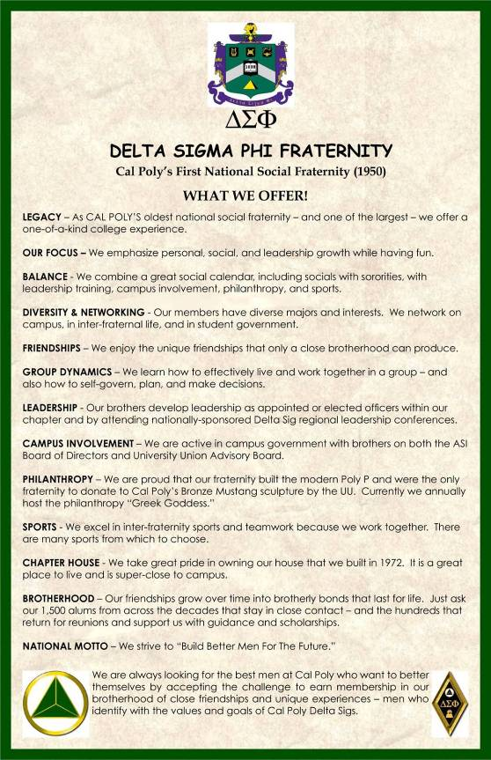

Risk-Management Measures Associated With Recruitment, New Members (Pledges), And New Initiates

(Addresses Cal Poly’s questions regarding Risk Management and Fraternal Management Process)

Since September 2012, when the chapter installed the recruitment message jointly-developed by alumni and undergraduates, the message has served as a first-line of risk-management.

Our recruitment message of the last two-and-a-half years is designed to attract the best men on campus – those whose personal belief system is in alignment with our program’s many goals.

This same message is also designed to screen-out those who only seek a party – those whose personal value system and decision-making process is focused on “my wants” and not “the group’s values”.

Two undergraduate brothers are mentioned by name in this report. The first is Gear McMillan, DSP class of Spring 2011, the member who was arrested on September 4, 2014. The second is Mitch Evanier, DSP class of Spring 2012, who has not paid member dues since May 7, 2014.

Relative to recruitment, we ask our partners in Cal Poly, and our National Fraternity, to appreciate the following five critical points about recruitment and membership dynamics:
- First, both these men joined prior to the “Culture Change” recruitment message, and new values-based decision-making program, at a newly ACB-mandated alcohol-free chapter property. These policies were installed September 2012. This recruitment message, and values program, has remained in force since that date.
- Second, men who joined us prior to, and subsequent to, September 2012 have had equal opportunity to participate, embrace, and promote this program.
- Third, we judge our undergraduate brothers by their behavior and commitment to our program, not by the date they joined our chapter.
- Fourth, while some older undergraduate brothers either chose, or were asked, to leave our roster, the best of their era played an essential role in guiding membership toward commitment to our new program. We thank these men.
- Last, with an extremely high percentage of four-year-graduates, most of the coming year’s membership will have been recruited to, versus having had to adopt, the “Culture Change” program and associated incentives for compliance and penalties for lack of compliance.

The following recruitment, New Member (pledge), and newly initiated brother risk-management procedures have been in place for many, many years. These are internal chapter controls and have proven very effective.

Bidding And Risk Management

Of those who seek to join our Fraternity, a careful screening is performed to select only the best candidates to issue bids to. Those who accept bids enter a probationary period and, per our National Fraternity, are called New Members. In the programs of other fraternities, these men may be called pledges.

New Members (Pledges) And Risk Management

Rush Week and Bidding timelines are mandated by the University. The chapter has a relatively short amount of time to fully assess a candidate’s character. When a New Member demonstrates conduct unbecoming a brother, a behavior in contradiction to our values or rules of conduct, he is asked to withdraw from the New Member class. As an example, in a recent class, 39 New Members were pinned, three were asked by the chapter to withdraw based on conduct issues, four voluntarily withdrew, and thirty-two were initiated as brothers.

Newly Initiated Brothers And Risk Management

During the quarter following initiation, new brothers are strictly required to observe but not participate in New Member (pledge) interactions with the chapter. New initiates are, in a sense, on a restricted status regarding any interaction with New Members. This system is effective in preventing newly initiated brothers from unknowingly acting inappropriately toward New Members (pledges).

Introduction Of New Program To Stress Philanthropy

In Fall Quarter 2012, the “Poly P Scholarship” was launched with ACB approval and funding support, to provide our alumni a collective means to give-back to Cal Poly.
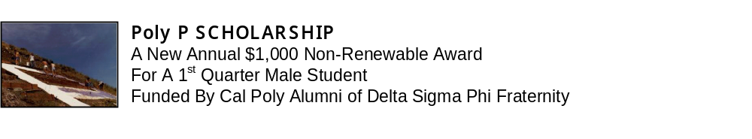

This merit-based public-service award for a non-fraternal male student honors our older brothers who built the “P” in 1957 while demonstrating the importance of philanthropy to our undergraduate brothers. Undergrad brothers assist alumni in judging and advertising this program. This program is not used as a recruitment tool, but to educate our undergrad brothers about how to recognize outstanding character.

To date our ACB and alumni have given $4,500 in educational awards to non-fraternal students.

PART 3: SEPTEMBER 2012 TO SEPTEMBER 2014 OPERATIONS

Chapter Chooses Values

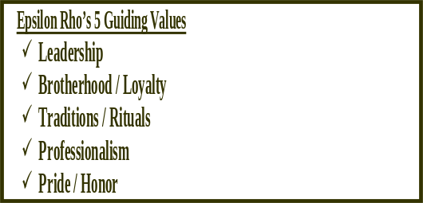
During the 2012-2013 school year, through joint discussions with ACB, the chapter debated and chose a set of five core values to live-by in chapter governance and personal conduct.

Our undergrads are showing a increased commitment to the chapter’s purpose, values, expectations, and rules. This is because they chose the values, defined behaviors that support the values, and regularly refer to them. Although a work-in-progress, this model has the potential to increase chapter independence in effective self-governance, improve risk-management, and promote undergraduate growth.

(source: Alumni Newsletter, Summer 2013)

April 2013: Campus Administrator Recognizes Delta Sigma Phi

Cal Poly’s Coordinator of Fraternity and Sorority Life, Mr. Diego Silva, addressed the alumni and undergraduate Brothers present at our April 20, 2013, ACB meeting. In a presentation to our Chapter President, Mr. Silva awarded our chapter with a SAFER Certificate. SAFER was established by Cal Poly in the late 1990’s and provides advocacy, educational programs, and confidential conversations about sexual assault or violence. The SAFER Certification recognized Delta Sigma Phi as a safe organization dedicated to ending violence against women and men. Mr. Silva also said, “The alumni organization of Delta Sigma Phi is one of the better organized and active alumni groups out of all of our Greek organizations.”

Spring 2013: ACB Encloses Property
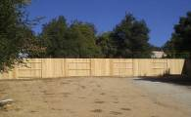
“The chapter’s backyard was open to the backyard of a rented house on Hathaway Street – where (chapter) house rules did not apply. Delta Sig brothers rented this house. At frequent and large Hathaway street-parties, our chapter property was a through-way for uninvited students. A fence was built, at a cost to ACB of $2,000, at the back of the chapter. This fence stops parties from spilling onto DSP property.”

(source: Alumni Newsletter, Spring 2013)

June 2013 On-Campus Volunteer Work Day

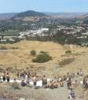
After obtaining permission from Cal Poly administrator Diego Silva, 75 members of Delta Sigma Phi performed needed repairs on the Poly P. The Saturday, June 1, 2013 voluntary 3 hour workday was spent cleaning and painting the “P”, pulling weeds and brush, and collecting refuse.

(Photo: 6/1/13 DSP workday)
(source: Alumni Newsletter, Summer 2013)

January 2014 – Poly P Scholarship


The chapter’s Engineered Leadership officer reported on the chapter’s experience with co-judging the Poly P Scholarship competition.

“Judging the Poly P Scholarship was both an honor and a learning experience. The hours of reading, analyzing, and ultimately deciding upon a winner were well worth it to bestow this award upon a worthy candidate. It is easy to get caught up. To lose sight of what’s important. To forget why we, as fraternity men, have the obligation and opportunity to better this world. But when we shook the hands of the young men who we deemed worthy of award, it suddenly became clear: the capacity to make a difference is at the very core of our brotherhood. You can write a check for a scholarship, but you cannot put a dollar amount on that.”

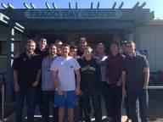
(source: Alumni Newsletter, Spring 2014)

2013-2014 Community Service

Effective Fall 2013, DSP has instituted a monthly community-service activity by Brothers and New Members (pledges). A frequent program is a day-of-service at San Luis Obispo’s Prado Day Center, a homeless shelter.
The photo is at the shelter.

(source: Alumni Newsletter, Spring 2014)

May 2014 Leadership Training
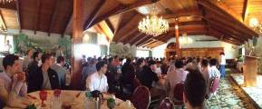

Ninety-plus undergrad brothers attended a three-hour Leadership Training seminar on Sunday, May 2, 2014. The event was sponsored by ACB and featured four speakers.
DSP Executive Director Patrick Jesse, DSP National Board Member Jim Larson, Cal Poly’s VP of Student Affairs Dr. Keith Humphrey, and the ACB President presented different topics.

(source: Alumni Newsletter, Summer 2014)

PART 4: 2014-2015 ACADEMIC YEAR (POST ARREST)

National Fraternity Mandates Chapter Probation And Member Education

Beginning in September of 2014, the chapter was put on an extended period of National Fraternity imposed probation. This continued through Fall Quarter 2014 and Winter Quarter 2015. During this period, intensive National and ACB and alumni-at-large involvement occurred in member-education and in extensive Chapter-bettering activities.

(source: Alumni Newsletter, Spring 2015)

Immediately Following Member’s Arrest – September 2014

Subsequent to the arrest, the ACB and the Chapter’s newly elected Executive Board of undergraduate officers required the brother to move out, which he did, pending resolution of the charge. Alumni leadership requested our National Fraternity place his fraternity pin (badge) on suspension, which had already been done as a matter of protocol.

(source: Alumni Newsletter, Spring 2015)

Chapter Improvement Plan Finalized – September 2014

Working closely with our National Fraternity, ACB developed a Chapter Improvement Plan that incorporated a significant list of required activities and accomplishments the chapter had to complete. These included National Fraternity led member-education for all undergraduates, multiple community service projects, adherence to strict probation standards, improved reporting requirements, personal commitment to the Fraternity’s rules and principles, and other requirements.

On Saturday, September 20, 2014, ACB members traveled to San Luis Obispo, met with the chapter’s Exec Board, presented and discussed the Chapter Improvement Plan, and gained the full agreement of membership to support the plan.

(source: Alumni Newsletter, Spring 2015)

Chapter Frequently Visited During Fall Quarter 2014

During Fall Quarter 2014, ACB met with Exec twice at the Chapter. The second meeting was Homecoming. ACB President Bob Veazie made a third visit, a solo surprise visit for a weekend to observe the chapter and reinforce member commitment to the plan.

National Fraternity Trains Chapter Membership In San Luis Obispo

National Director of Risk Management Cameron Warner and National Chapter Development Coordinator Bryan Witt also visited the Chapter during Fall Quarter 2014. On November 8 they led our men in a mandatory six-hour member-training. ACB arranged for this training to take place at Madonna Inn’s Garden Room and paid the $4,000 in associated meeting-room and meal costs.

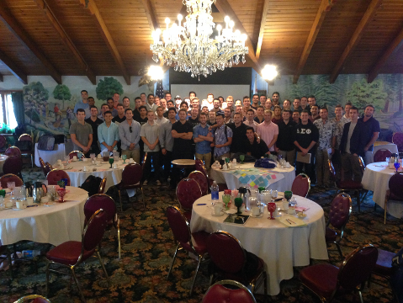

(source: Alumni Newsletter, Spring 2015)

Chapter President’s Report To National Fraternity – December 2014

“The combination of both internal and external efforts is impressive! As you can see, events such as RLA’s (group leadership training), G&O’s (Goals and Objectives Meeting With ACB), and the completion of the sports court are all internal facing measures, focusing on our own professional and personal development.

Externally, we organized one large philanthropy (Bowling for Breast Cancer) as well as volunteered the entire house for events in Arroyo Grande, Downtown SLO, and the SLO Food Bank. In addition, Epsilon Rho supported 3 other philanthropies benefiting the Alpha Phi Foundation, Girls on the Run, and the Make-A-Wish Foundation.

On top of all of this, we have made significant efforts to improve security in the house by installing better doors and locks on all entrances, as well as updating our Internet networks to High- Speed FIBER. Our "Alumni-Stay-Room” (Gear’s old room) has now been turned into an “Academic Study Room.” Our newly elected House Scholar has also made efforts to bring onboard a new Academic Advisor, Taryn Stanko. Focusing on Business and Negotiations, Professor Stanko will aid our members in becoming more professional and ready for their postgraduate challenges.

It certainly has been an eventful and exciting quarter for everyone at Epsilon Rho! We look forward to the next quarters and the different challenges and growth they will bring. As a quick look into our year, we already have plans for two major philanthropies: Fight for Life and Greek Goddess. Also in the works is a new internal study on Epsilon Rho postgraduate jobs and salaries.”

(source: Alumni Newsletter, Spring 2015)

Chapter Converts Bedroom Into Study Room – November 2014

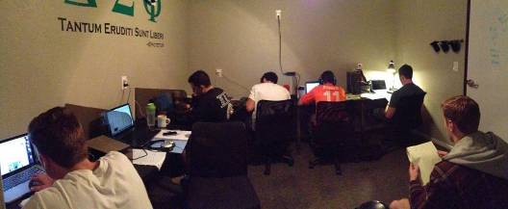

On their own initiative, the Chapter converted the empty bedroom of the arrested member into a Scholar Study Room during the second half of Fall Quarter 2014. The ACB gave financial support for the furniture and the Alumni Association purchased monitors and associated electronic components. Delta Sigma Phi’s Fall Quarter 2014 GPA was higher than the Cal Poly All-Men’s average.

(source: Alumni Newsletter, Spring 2015)

Chapter Raises $4,000 For Cancer Research – Fall 2014

A chapter officer reported, “In recognition of National Breast Cancer Awareness Month, DSP hosted our annual Bowling for Breasts Philanthropy. With participation of every sorority, we were able to raise $4,000 to fund breast cancer research. Over 300 attended.”

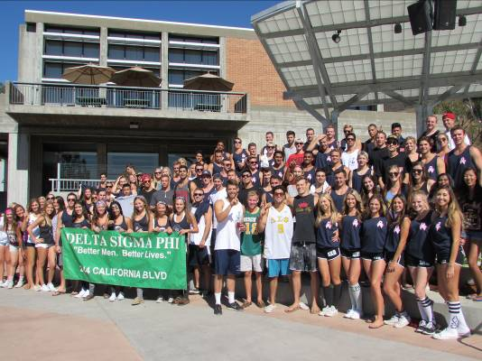

(source: Alumni Newsletter, Spring 2015)

Chapter Returns Tradition Of Service To Children – Fall 2014

For Halloween, 2014, a chapter officer reported on membership’s decision to return our many decade tradition of helping children.

“This year, the City of Arroyo Grande asked our brotherhood to setup and run their yearly Halloween Carnival. In addition to constructing the Haunted Maze and face-painting booths, our brothers ran the carnival and interacted with the community.”

(source: Alumni Newsletter, Spring 2015)

DSP National Grand Council President Visits Chapter – January 2015

On January 22, 2015, Delta Sigma Phi’s Grand Council President wrote our chapter’s alumni leaders about his chapter visit the day before.

“Gentlemen -

I had the opportunity to visit your Chapter yesterday afternoon and was suitably impressed! Epsilon Rho seems to be doing very well, the men were getting ready for a Rush event and the new study room was even in use. Evidence of the use of the room is attached! Great guys and what looked like a great facility. I was pleased to meet Derek and several of the other brothers. Thanks for arranging it.”

Tom Cycyota
PRESIDENT & CHIEF EXECUTIVE OFFICER”

(source: Alumni Newsletter, Spring 2015)

Chapter President Travels To National For Training – February 2015

Chapter President Derek Morefield reported:

“On February 6-8 I attended Delta Sigma Phi’s President’s Academy at chilly Camp Tecumseh in Indiana. There at the academy, leaders of Delta Sigma Phi from all over the United States met to discuss broad issues such as individual strengths, and more narrow issues such as managing a Chapter meeting. What was most important out of the trip were the discussions that occurred in small groups and the accompanying lessons that needed to be learned. Immediately following the President’s Academy, we at Epsilon Rho went hard to work creating a local Strategic Vision for the next 1-5 years, restructuring the way we did Chapter meetings, have implemented a new project management software (ASANA), and are working to pass a Chapter budget for the 2015-2016 year. It proved to be an informative and productive trip that already has seen benefits in our Chapter.”

(source: Alumni Newsletter, Spring 2015)

ACB Continues Unannounced Monthly Chapter Visits To Check On Compliance

ACB Treasurer Chris Hardy visits the Chapter monthly on an unannounced basis as part of a continuing ACB compliance inspection. These unannounced visits are termed “audits” and inspect the Chapter house for alcohol (dry house – alcohol not allowed) and illegal drugs (obviously not allowed).

(source: Alumni Newsletter, Spring 2015)

ACB Installs Chain-Link Fence At Chapter As Part Of Continuing Risk-Management Program – Winter 2015

ACB Treasurer Christopher Hardy explains:

“We spent $17,000 replacing all perimeter wooden fencing with chain-link fence (and) installation of an automatic security gate (across driveway). We were having issues with people cutting through the property and even homeless people stealing items from the property.”

ACB Advisor Chris Patterson told alumni:

“$17,000 is a cheap insurance policy – relative to the sacrifice and care that 65 years of Delta Sigs at Cal Poly have invested into the Chapter. The objective of enclosing and being able to restrict access to the Chapter’s grounds is not to keep the party in – this is a dry fraternity house. The objective is to keep the party, and its attendant risks, out! We have tools to manage risks within our membership and our men have responded very well. Providing perimeter security - in the form of fences and gates - was necessary to manage external risks over which alumni and membership have no control.”

(source: Alumni Newsletter, Spring 2015)

Off-Campus Block Party Surprises Everyone – Saturday, March 7, 2015

CBS national evening news on Saturday, March 7, broadcast that a major block party occurred in San Luis Obispo, near the campus, early that morning. Initial reports by various news organizations said that 1,000 to 2,000 students participated. The party is reported to have begun at about 4:30 a.m. and continued until about 6:30 a.m. when authorities responded to noise complaints and a garage roof collapse that injured some students. Students were on roofs of houses and garages about two blocks from campus.

The block party was held along a several-block length of Hathaway Street. The DSP Chapter house is on a mostly parallel street, one block further away from campus than Hathaway.

An Exec officer reported to alumni that the front driveway gate and rear pass-gate had been closed and locked the night preceding the pre-dawn party. The ACB Treasurer reports that he has receipts showing the chapter’s membership were out-of-town, about 30 miles away at a group campground, on an overnight leadership retreat, at the time of the party.

(source: Alumni Newsletter, Spring 2015)

Chapter President Reports On Block Party – Sunday, March 8, 2015

“DSP and 244 California (Chapter House) had NOTHING to do with this (block party). Delta Sigma Phi was not responsible for the event.”

(source: Alumni Newsletter, Spring 2015)

University Puts Chapter On Cease-And-Desist Status As Fraternity – Tuesday, March 10, 2015

On Tuesday, March 10, 2015, Cal Poly’s Coordinator of Fraternity and Sorority Life sent the following message to DSP’s Chapter President at Cal Poly.

“As a response to allegations regarding an alleged violation of the Cal Poly Fraternity and Sorority Life Alcohol and Drugs Policy, the Epsilon Rho​ chapter​ ​of Delta Sigma Phi ​is Under Investigation. According to university policy, “a Chapter may be placed under investigation if the Dean of Students, Fraternity and Sorority Life Office has reason to believe that the Chapter has directly violated or may be connected with a violation of university policy. If a judicial hearing is initiated by the Dean of Students, Fraternity and Sorority Life Office the Chapter will remain under investigation status until the hearing has concluded.”

Effective today, March 10, 2015 the Chapter should suspend all functions and may not conduct any events, activities, or participate in Intramural Sports. We will work with the Chapter officers, national headquarters, and local authorities to ensure a timely investigation.

Please let me know if you have any questions or would like to set up a meeting.

Thank you for your cooperation.”

(source: Alumni Newsletter, Spring 2015)

Fraternity Mug Of In-Active Past Member Returned

It was not until the May 8, 2015, Cal Poly hearing that our Fraternity became aware that the University believed Delta Sigma Phi was involved in the March 7, 2015, ill-advised block party. During the hearing, Dr. DeCosta returned to our chapter President a DSP mug that belonged to Mitch Evanier. This past member of the Fraternity has not paid dues since May 7, 2014, nor attends meetings. His mug was reported by the University to have been found on Hathaway Street after the block party. As we establish in this report, our Fraternity was not involved in this block party.

Chapter Winter Quarter 2015 GPA Announced By University

During Fall Quarter, 2014, the chapter’s GPA was higher than the Cal Poly All-Men’s Average GPA, and in the top third of IFC GPA’s.

During Winter Quarter, 2015, the chapter’s GPA rose, to an average of 3.02. This was again higher than Cal Poly’s All-Men’s Average GPA, and the second highest in IFC.

(source: Cal Poly)

University Interviews About 20 Chapter Members – April / May 2015

During Spring Quarter, 2015, the University separately interviewed about 20 chapter members regarding the 2013-2014 academic year activities of the member arrested on September 4, 2014. Delta Sigma Phi’s recently elected Epsilon Rho Chapter President reported to ACB on Thursday, May 28, 2015, that he was told by the Dean of Students that all interviews with and investigations of chapter members were being dropped for lack of evidence.

(source: Bob Veazie, Acting ACB President)

Payments To Members For Chapter Work - And Scholarships

From our inception in 1950 at Cal Poly to the present day, our chapter promotes the academic mission of our members by assisting with their educational costs.

For this 2014-2015 academic year, our program made the following investments in the costs of our men’s education:

Chapter Officers are compensated a total of $14,040 for their services.
Commissary Steward and members who cook are compensated $5,400 a year.
Members who live at the chapter house pay 25% to 35% lower rent than market.
Alumni give five (5) $1,000 scholarships a year to reward and incent character.

This adds up to $25,000 in direct compensation, and $14,500 in rent reductions using the more conservative estimate of 25% in housing savings.

This totals nearly $40,000 in annual fraternal support for the academic mission of our members. This program encourages work ethic, promotes leadership development, provides a less expensive housing option to those in need, and rewards character and service.

(source of values: ACB Treasurer, May 2015)

PART 5: CHAPTER PROPOSAL FOR FUTURE RISK-MANAGEMENT PROGRAM CHANGES

On their own initiative, our chapter’s membership developed new policies in the wake of the arrest of a brother last September. These included forming a judicial review board of peer review to promote member responsibility and accountability, a new Engineered Leadership Exec position, a new House Scholar Exec position, etc.

During this same period, the ACB has also established new policies, such as the Issue Elevation Program. The chapter chose three alumni to be able to elevate issues to, outside of the usual Exec Board reporting process to alumni. The names and contact information of these alumni are posted at the chapter.

However, after reflection, ACB officers now propose two additional policy changes for future chapter operations. The first is to make full use of our National Fraternities recently developed Volunteer Engagement Program to bring more Chapter Advisors on-board to provide greater oversight of our chapter. The second proposed program change is a two-year test program of not pledging first quarter freshman.

In the first proposed program change, we will avail ourselves of the National Fraternity’s new system of attracting Chapter Advisors to assist our current Lead Chapter Advisor in his day-to-day oversight and management of chapter operations. Currently we only fill one of the five Advisor positions, that of Recruitment and Retention Advisor. We are seeking alumni, and non-fraternal volunteers, local to SLO, as candidates for the other four Advisor positions, and each position has a special area of focus. We accept that out-of-town ACB officers, who establish strategic direction for the chapter, need assistance with increased local oversight of day-to-day operations. We were without a Lead Chapter Advisor for approximately a year-and-a-half prior to recruiting an excellent officer in Mr. Bill Bradley in April, 2015.

The second proposed program change is associated with the unique risks of recruiting and initiating first quarter freshmen. We propose a two-year test program wherein we participate in the University-managed Rush Week.

Freshman Recruitment Proposal

In recognition of the risk which first-quarter freshmen present to the campus / community / fraternities, our chapter offers to demonstrate to Cal Poly and fellow IFC members a two-year test program on rush/recruitment risk management. As we successfully did during Fall Quarter 2014, we will participate in the Fall Rush Week - but require any candidates wanting to join our chapter to wait until Winter Quarter to receive New Member (pledge) pins and begin their pledgeship. The best of these candidates will comprise a Winter class. Our Spring class will result from the IFC Spring Rush Week. There will be no Fall class during 2015 and 2016. We will encourage first-quarter freshmen to use Fall Quarter to become adjusted to living away from home, to adjust to their university-level academic work load, and to learn more about what Delta Sigma Phi can offer them. During this period, our chapter can learn more about the quality and character of these candidates.

CONCLUSION

Our ACB and chapter focus since Carson Starkey's death, and especially since September 2012, has been on alcohol-risk education and control. Our focus has been on the student health and safety issues of alcohol abuse, binge-drinking, supporting Aware, Awake, Alive's mission and voice, and promoting and maintaining a dry fraternity house for the safety of members and their guests

Since 2012, the first year of our charity golf tournament for Julia and Scott Starkey’s Aware, Awake, Alive Foundation, our alumni and undergraduate brothers have given an increasing annual donation, from $5,000 in 2012 to $12,000 in 2015 – to bring voice to their message and promote the health and safety of all Cal Poly students.
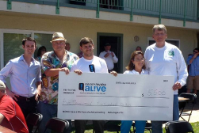
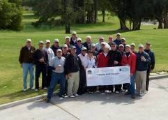

Until the drug-related-arrest of a chapter member last summer, the first such instance in 65 years at our Cal Poly chapter, alumni leaders did not realize the risk that drugs present to our nation's current generation of college students. Alumni leadership now recognizes this issue merits ongoing drug education for members. We further agree that we must apply the full measure of our brotherhood influence in making alumni expectations of a drug-and-alcohol free chapter environment absolutely understood and agreed to by membership.

It is our sincere hope that we have completely addressed the important questions asked by Cal Poly of our student organization in the May 8, 2015 hearing. These questions were about our fraternal management process, the health and safety of members and the student body, and the value our Fraternity provides to members, the student body, Cal Poly, and the community.

Based on the new information presented in this document that was not prepared in time to convey to Dr. DeCosta for the hearing, we respectfully request that the University’s May 12, 2015 initial decision to revoke our campus recognition be overturned. We ask that our student-organization, which has worked tirelessly to represent the best ideals of Cal Poly, while discovering and correcting our faults - not be penalized for individual actions not in compliance with our beliefs, values, and goals.

Respectfully,

Alumni Corporation Board
Epsilon Rho Chapter
Delta Sigma Phi Fraternity
Cal Poly / SLO

Mr. Bob Veazie
ACB Vice-President / Engineered Leadership, Acting President
Owner, People Powered Leadership Consulting
DSP Class of 1976
followthearrow@hotmail.com

Mr. Rick Rengel
ACB Vice-President / Housing
Architect, Owner Rengel+Co Architects
DSP Class of 1975

Mr. Ray Calande
ACB / Alumni Chapter President
Manager / Lockheed-Martin
DSP Class of 1974

Mr. Bill Bradley
SLO Businessman
ACB Chapter Advisor
DSP Class of 1963

Mr. Christopher Hardy, CPA
ACB Treasurer
Accountant, Damitz, Brooks, Nightingale, Turner, and Morrisset
DSP Class of 2005

Mr. Ian LeMay
ACB Secretary
Director of Member Relations, California Fresh Fruit Assn.
DSP Class of 2005

Mr. Chris Patterson
ACB Recruitment Advisor
Accountant / Retired
DSP Class of 1973

